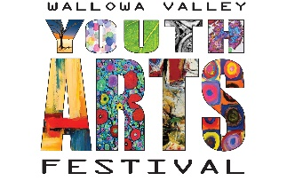
ENTRY FORM 2021

Drop off art: Art may be dropped off at Josephy Center for Arts and Culture starting Monday March 22nd. All art must be received by Tuesday, April 6th at 5:00 pm. No art will be accepted after April 6th! Contact Megan Wolfe at coordinator@josephy.org or (541)432-0505 if you would like to volunteer to help hang artwork!

ART FESTIVAL Details
Josephy Center located at 403 N. Main St., Joseph
Free Admission – Donations Welcome - Open House
Saturday, April 10th 12:00 to 4:00 pm
The Youth Art Show will hang for 8 days. Art will be available for pick up Monday, April 19th from 10am-4pm.

Categories
Painting • Drawing • Photography • Ceramics • Collage • 3-Dimensional Woodworking • Printmaking
Mixed Media • Sculpture • Hand-Built Items • Calligraphy • Fabric Art • Metal Work • Jewelry • Glass
Students in grades k-12 may enter 1 piece of Art.
All 2-dimensional artwork must be mounted on sturdy board and/or matted and ready-to-hang.
Visit www.joseph.org/events/wallowa-valley-youth-arts-festival for inspiration on getting your piece ready to hang.
Age Groups
Special Needs; K-1st; 2nd-3rd; 4th-6th; Junior High; High School
Categories will be combined and judged for each age group. Each age group will receive
1st, 2nd, 3rd Place and Participation ribbons. All entrants will receive a ribbon. People’s Choice, Judge’s Choice and Director’s Choice will receive special recognition.
Art Sale
We encourage the sale of work (not required) - 100% of the sale price will be for the artist to keep.
If you have any questions please contact Megan Wolfe at coordinator@josephy.org or (541)432-0505.
---------------------------------------------------------------------------------------------------------------------------------------
Entry Form (one per art piece).
Name of student___________________________________ Name of School___________________________ Parent/Guardian___________________________ Parent Phone #_______________ Age____ Grade______
Mailing Address_______________________________City_________________________Zip Code__________
Email_________________________________________
Art Tags (one per art piece):
Name
Title

Name of school Grade

Price or Not For Sale Sale
$ (circle)

